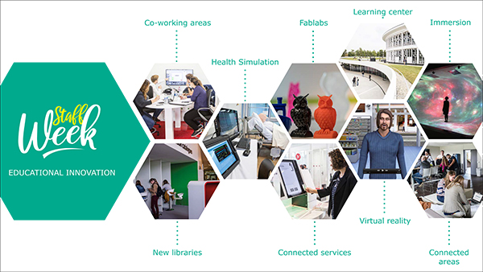
Dear European colleagues,
The University of Lille in France, a multidisciplinary university of excellence at the heart of Northern Europe, is proud to invite you to our 2021 online staff week from the 23rd to the 24th of June 2021. This event is open to academic and staff members both from partner and non-partner institutions. With an intensive program focused on educational innovation, this staff week will give you the opportunity to get familiar with the innovative learning spaces and the research fields of the University, emphasizing in health program simulation devices. During this staff week, you will be able to discover the advanced multidisciplinary research programs and spaces to test and develop learning initiative as well as participate in the roundtable on the impact of COVID19 crisis on teaching practices and the organization of universities. Also, dynamic scenarios and activities are proposed to get to know French culture.
You always can find more information in the preliminary program.
We welcome lecturers, teachers and administrative staff within the International Education programs and other related areas as pedagogical innovation departments and teacher education.
How do I register?
By filling in the application form available here.
Deadline for registration: may 28th 2021
After registrations, a selection committee will be formed to select final participants. If your profile and motivations correspond to our event, you will receive further information.
If you have any questions, please, do not hesitate to contact us.
We warmly welcome you!


In partnership with 
--

Zoé Bouvard
Stagiaire relations internationales
Faculté des sciences et technologies - Université de Lille
zoe.bouvard@univ-lille.fr | sciences-technologies.univ-lille.fr
Rez-de-chaussée - Bât. FST – 59655 Villeneuve d'Ascq

